'Total requests per hour for each tag and request type with duration'

**select** **max**("count") **as** "max_in_hour", request_type, tag, **max**(duration) **as** "max_duration_total"

**from** (**select** **count**(*) **as** "count", **sum**(duration) **as** "duration", **date_trunc**('hour', **timestamp**), request_type, tag

**from** logs

**group** **by** **date_trunc**('hour', **timestamp**), tag, request_type)

**group** **by** request_type, tag;

'Total requests per hour for each tag and request type and also with relation of all request for specific path within an hour to all requests within an hour'

**with**

requsts_statst **as** (

**select** **count**(*) **as** "count", **sum**(duration) **as** "duration", **date_trunc**('hour', **timestamp**) **as** "time", request_type, tag

**from** log_analisys.logs

**where** source_file = 'nginxlog'

**group** **by** **date_trunc**('hour', **timestamp**), tag, request_type

),

all_request **as** (

**select** **sum**("count") **as** "all_count","time" **from** requsts_statst **group** **by** "time")

**select** r.request_type,r.tag,r."time",r.**count**,(r.**count**/a.all_count)*100 **as** req_percent **from** requsts_statst r **join** all_request a **using** "time";

WITH – Common Table Expression

Позволяет создать таблицу, заранее. Сродне **select * from (select…)**, но только мы заранее можем создать несколько таблиц

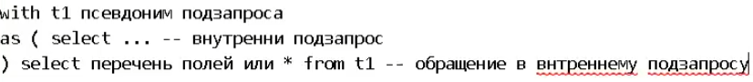

Сложный WITH – позволяет создать несколько таблиц с разными условиями, а потом их объединить

